**Quadrant analysis**

Look at profit over 2017 and 2018 and see who’s improved over that time, who’s dropped off, Whether there are some constant across the profit across those two years.

Create the following calculated fields

2017 Profit

IF YEAR([Order Date])=2017 THEN [Profit] END

2018 Profit

IF YEAR([Order Date])=2018 THEN [Profit] end

Drag 2017 Profit to the columns and 2018 Profit to the rows and sun-category and state to the marks card

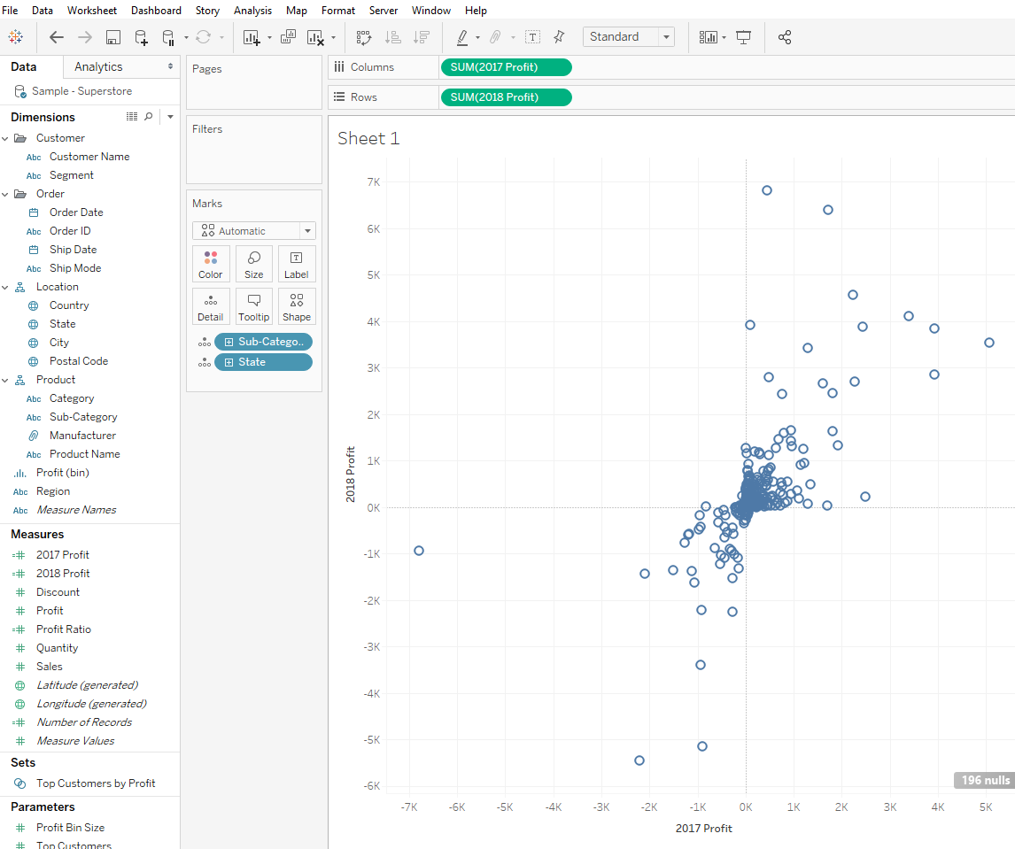

The upper left shows the sub categories that are doing great and the lower shows the ones that are not doing great.

To make the visualization more interactive we can look the data as percentiles rather than individual profit values.

We can give the highest profit as 100th percentile working down to the lowest 0th percentile of the lowest profit as it will help sort out the data at the center.

Change the computing using percentile for the 2018 Profit.

As we need to compute using both state and Sub-Categories edit the table calculation as follows.

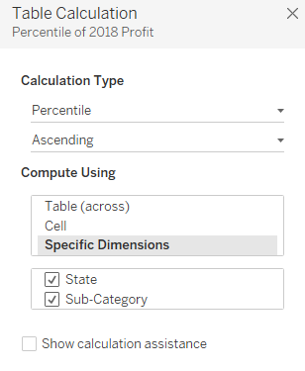

Repeat the same for 2017 Profit

To know the number of items we are dealing in each state Drag the number of records to the size shelf and change the marks type to circle.

Drag the sum(2017Profit) and sum(2018 Profit) from the columns and rows shelf to the measures and rename it as 2017 Profit Percentile and 2018 Profit Percentile and change the number format to percentage with decimal place of 1. Drag the newly name field from the measures shelf to the columns and rows shelf after removing the existing calculations for the rows and columns shelf.

As we are doing Quadrant analysis we can drag some reference lines from the analytics tab to the 2017 Profit Percentile shelf and 2018 Profit Percentile shelf and adjust that to 0.5 as 50% is the median value. Edit the reference line to hide the labels.

Edit both axis to fixed between 0 and 1.

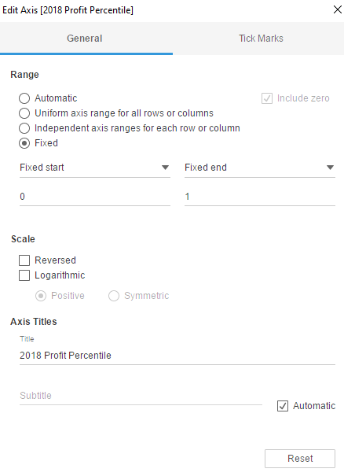

Format to remove the grid lines from the view.

Create a new calculated field to change the colour.

Color

IF [2017 Profit Percentile]<=0.5 and [2018 Profit Percentile]<=0.5 THEN 'Bottom Left'

ELSEIF [2017 Profit Percentile]>0.5 and [2018 Profit Percentile]<=0.5 THEN 'Bottom Right'

ELSEIF [2017 Profit Percentile]<=0.5 and [2018 Profit Percentile]>0.5 THEN 'Top Left'

ELSEIF [2017 Profit Percentile]>0.5 and [2018 Profit Percentile]>0.5 THEN 'Top Right'

ELSE 'ERROR'

END

Drag the color field to color shelf and exclude the error as there are no error values.

Annote the Quadrant anD perform analysis.